Lab name：**OPA Astable Multivibrator** Student ID： B11102112 Name: Chiajui Lee

# Purpose

The objectives of this experiment are to:

1. Observe and analyze the operating principles of an operational amplifier (OPA) astable

Multivibrator.

B. Verify its oscillation frequency formula.

C. Demonstrate square wave generation using this circuit configuration.

The OPA astable multivibrator represents a fundamental oscillator circuit valued for its simple architecture, operational stability, and adjustable output characteristics, with practical applications spanning timing circuits, pulse generation, and phase-locked loop systems. This investigation provides both theoretical insights into oscillator design and practical skills for waveform generation in electronic systems.

1. Steps
2. Construct the specified circuit using operational amplifiers (OPAs) and resistors.
3. Connect the power supply to provide +10V to the 𝑉+ terminal and -10V to the 𝑉− terminal of the OPA.
4. Measure the output results using an oscilloscope.

# Data

## Square Wave Generator

* 1. 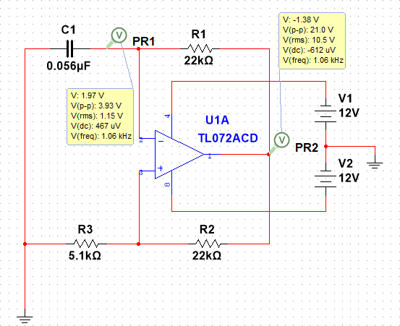Output Square-wave
  2. Output waveform

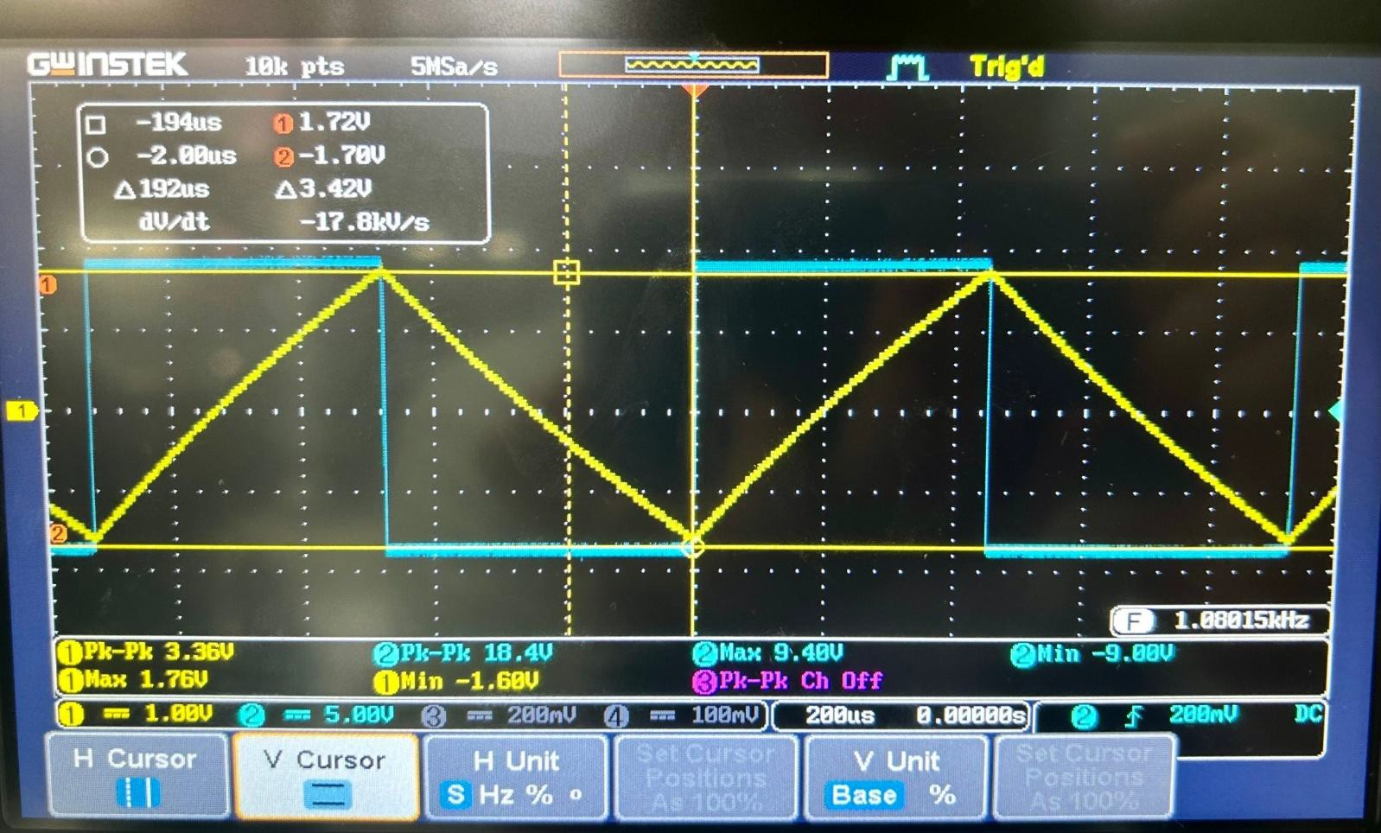

* 1. Measured value

|  |  |  |
| --- | --- | --- |
|  | Measured Value | Theoretical Value |
| Frequency | 1.08kHz | 1.06kHz |
| Capacitance Voltage | +1.72V , -1.78V | |
| Output Voltage | 9.10V , -8.70V | |

## Square Wave Generator + Integrator Circuit

1. Output Triangle-wave

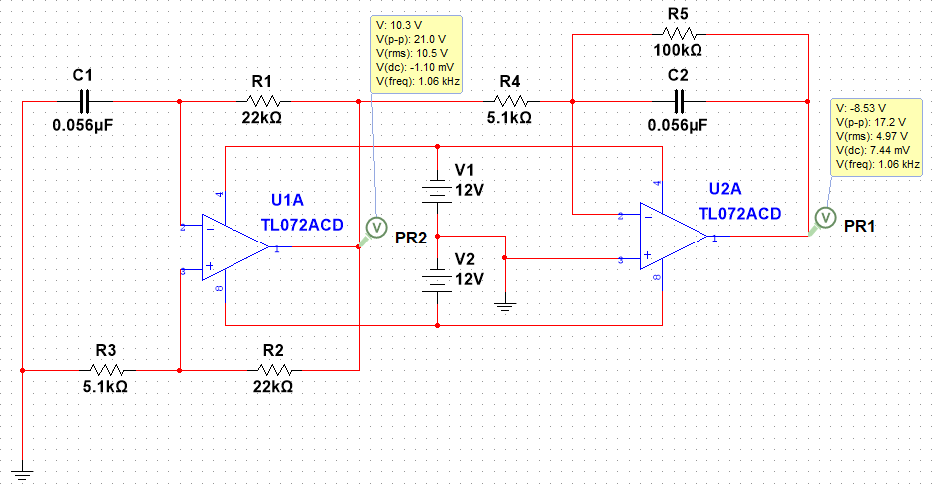

1. Output waveform

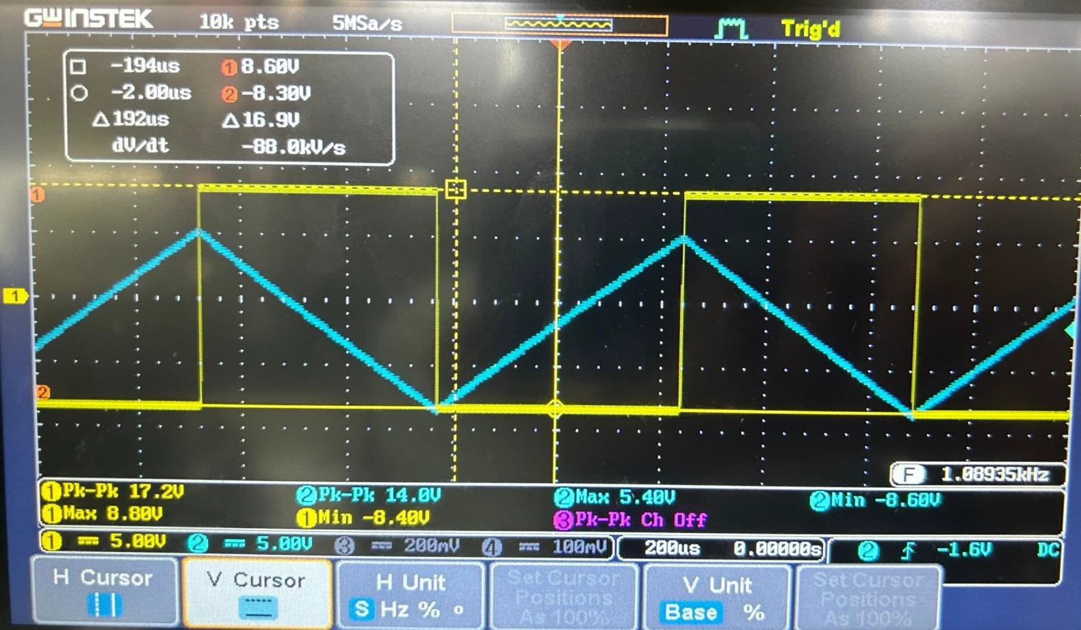

1. Output voltage

|  |  |
| --- | --- |
|  | Measured Value |
| Vo1 | 8.6V , -8.38V |
| Vo2 | 5.20V , -8.50V |

## Square Wave Generator Applications

1. Output duty cycle = 83.3% Pulse-wave

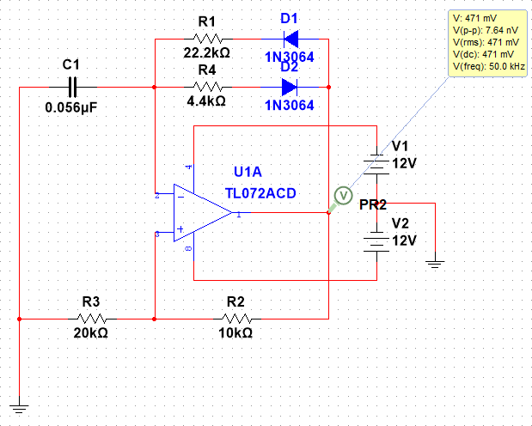

1. Output waveform

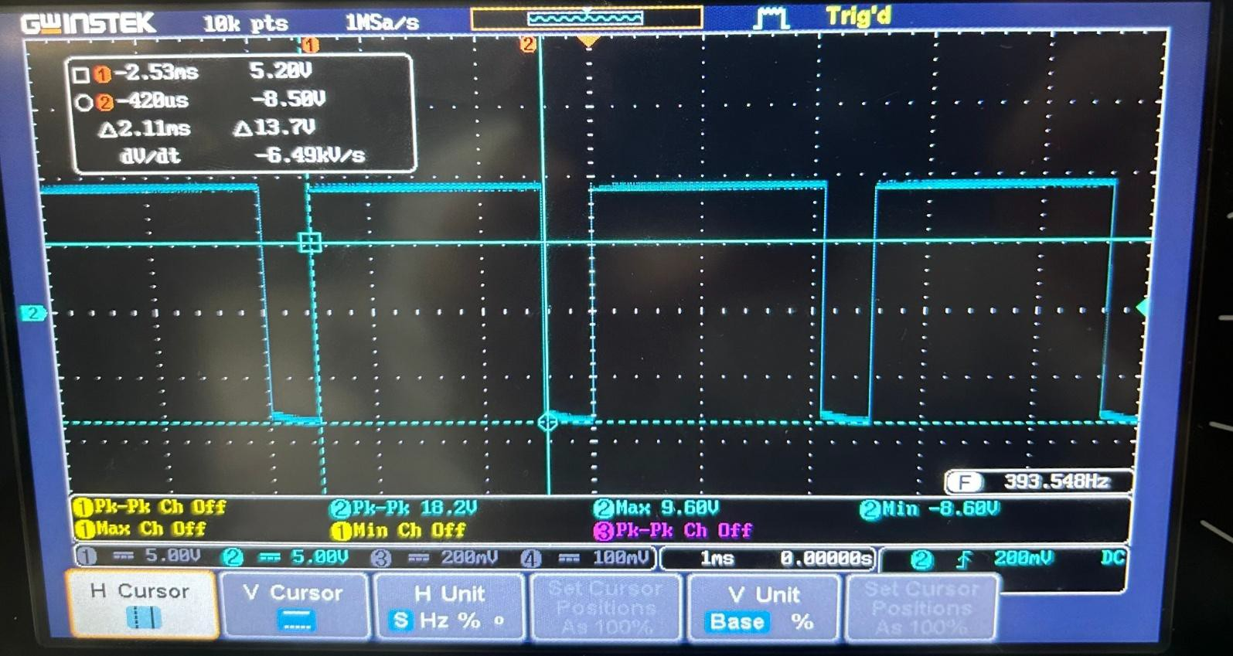

1. Output voltage

|  |  |  |
| --- | --- | --- |
| High-level time | Low-level time | Proportion |
| 2.11ms | 440µs | 4.79:1 |

# Questions and Discussion

## Why does the OPA output sometimes have unequal maximum and minimum values?

Reasons for Unequal Maximum/Minimum Output in OPA Circuits:

1. **Offset Voltage**  
   The input offset voltage (a small DC voltage present at the input terminals due to internal transistor mismatches) becomes amplified by the circuit's gain. For example, a 1mV offset in a circuit with 100x gain produces a 100mV output deviation, causing measurable asymmetry between positive and negative peaks.
2. **Bias Current**  
   The input bias current (required for internal transistor biasing) flows through external resistors, creating additional voltage offsets. With 1nA bias current through a 1MΩ resistor, this generates 1mV of unintended offset voltage. In high-impedance circuits, this effect becomes particularly pronounced.

# Reflections

During this lab session, we learned how to use an OPA to construct both a square wave generator and an integrator circuit. Since we had previously encountered similar circuits in both lectures and lab sessions, the experimental setup was familiar to us.

For the bonus task, we faced the new challenge of modifying the square wave generator into a pulse generator as specified in the requirements. After careful consideration and research, we discovered an online solution utilizing two diodes to control the capacitor's charging time for both positive and negative voltages. To achieve the correct ratio, we spent considerable time experimenting with different resistor values to find the optimal configuration.